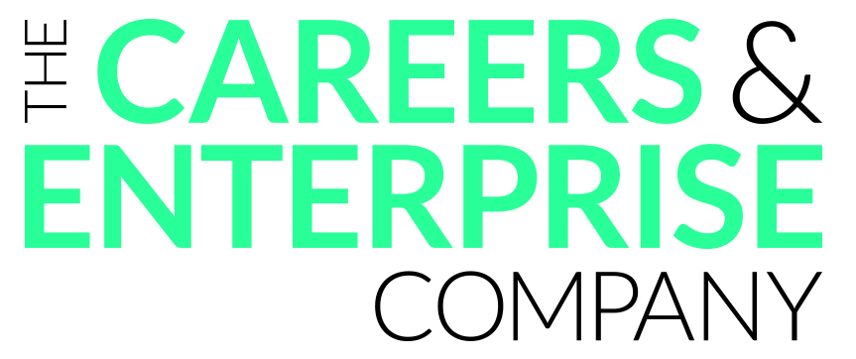
Agenda for School and Enterprise Coordinator Meeting
School name
Date
Attendees

Annual agreed priorities
The school will focus on achieving the following benchmarks this academic year:
Gatsby Benchmark
Gatsby Benchmark
Gatsby Benchmark
Other priorities

Agenda
Please bring your updated Compass report, audit materials, recently received evaluations from activities and any other documents of interest to the meeting.
Review notes and actions from the last meeting
Compass and Tracker

EC/LEP new events / information
- CEC Targets:
  - 6 benchmarks fully achieved –
  - BM1 75% -
  - BM5 75% -
  - BM6 65% -
- Compass+
- SEND groups
- At risk learner support
Any Other Business

Action points and next meeting date

Notes
Priority Actions before next meeting | Who

