Your Name:
Name of your School:
Date of activity:

How long was the activity for?

Name of Employer:

What have you been up to today? Go ahead and either write or draw about it, or even both.

How much did you enjoy it (circle your choice)?

1 2 3 4 5

What did you enjoy the most? Write or draw your answer.

What did you enjoy the least? Write or draw your answer.

What would make the activity better? Write or draw your answer.

What have you learned from the activity? Write or draw your answer.

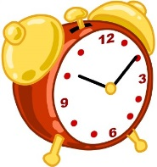
How did you find the length of the activity?

Too Short Just Right Too Long

Would you recommend the event to a friend?

Yes No
Have you ever thought about the adult world of work before the event?

Yes No

If yes, what did you want to be when you grow up? Write or draw your answer.

What are your thoughts about work now after the activity?

Do you have any other thoughts about the activity you took part in today?

Thank you for taking the time filling this in, your feedback is greatly appreciated.

